Apache, MySQL, Python Web Server

Kyle Au

ka8324

201314127

CS4754

**How To Run:**

1. Make sure ka8324.html is in /var/www/html and ka8324.py is in /var/www/cgi-bin folder for your apache server.
2. Make sure your apache server is on and working in your browser.
3. Click ka8324.html file to open it on the browser.
4. Type an input in the text box, following the instructions printed above the text box.
5. Hit the submit button.
6. Watch the html send the input to the server, python interpret it and query MySQL database SupplyDB for your input and return and display it on the web page on the webpage.

**Example Query A:**

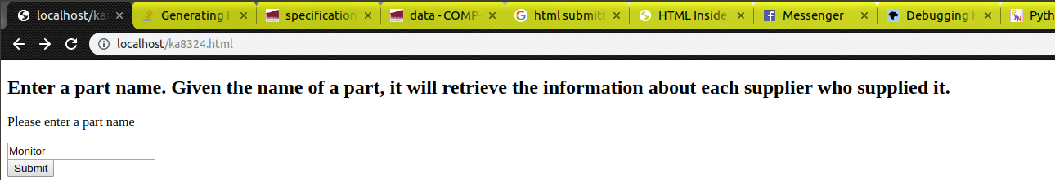

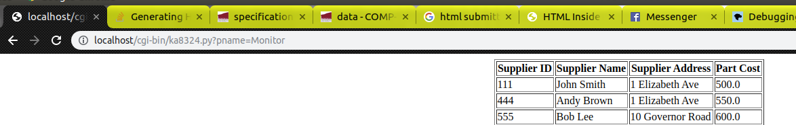

**Example Query B:**

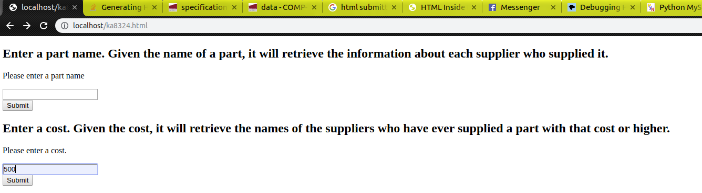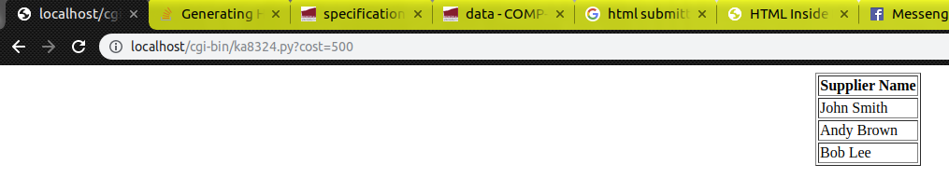

**Example Query C:**

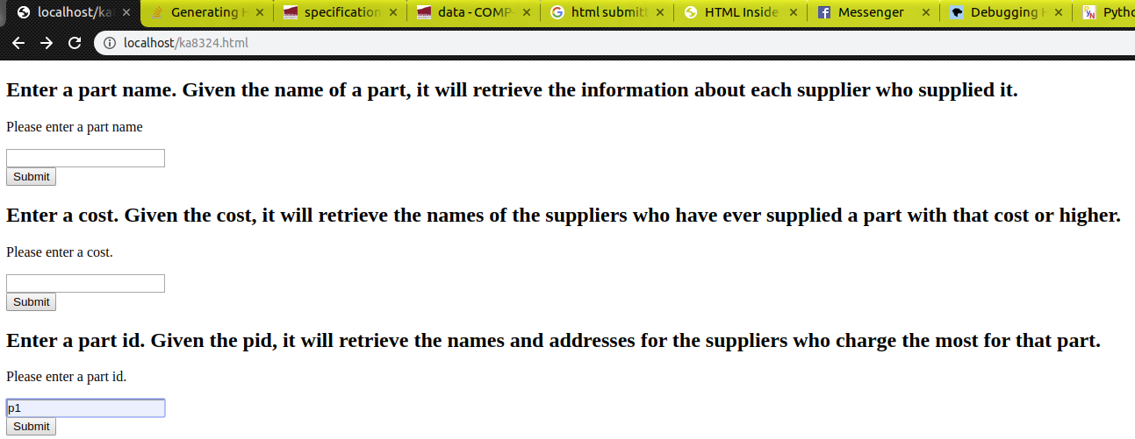

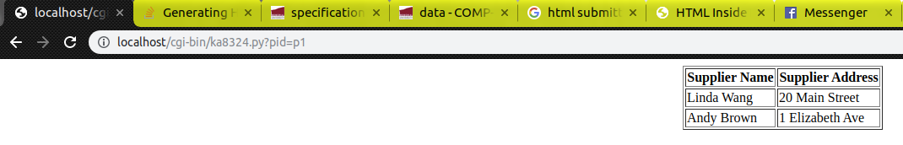

**Example Query D:**

MySQL query works in the terminal using MySQL but doesn’t run correctly in my Python CGI code.

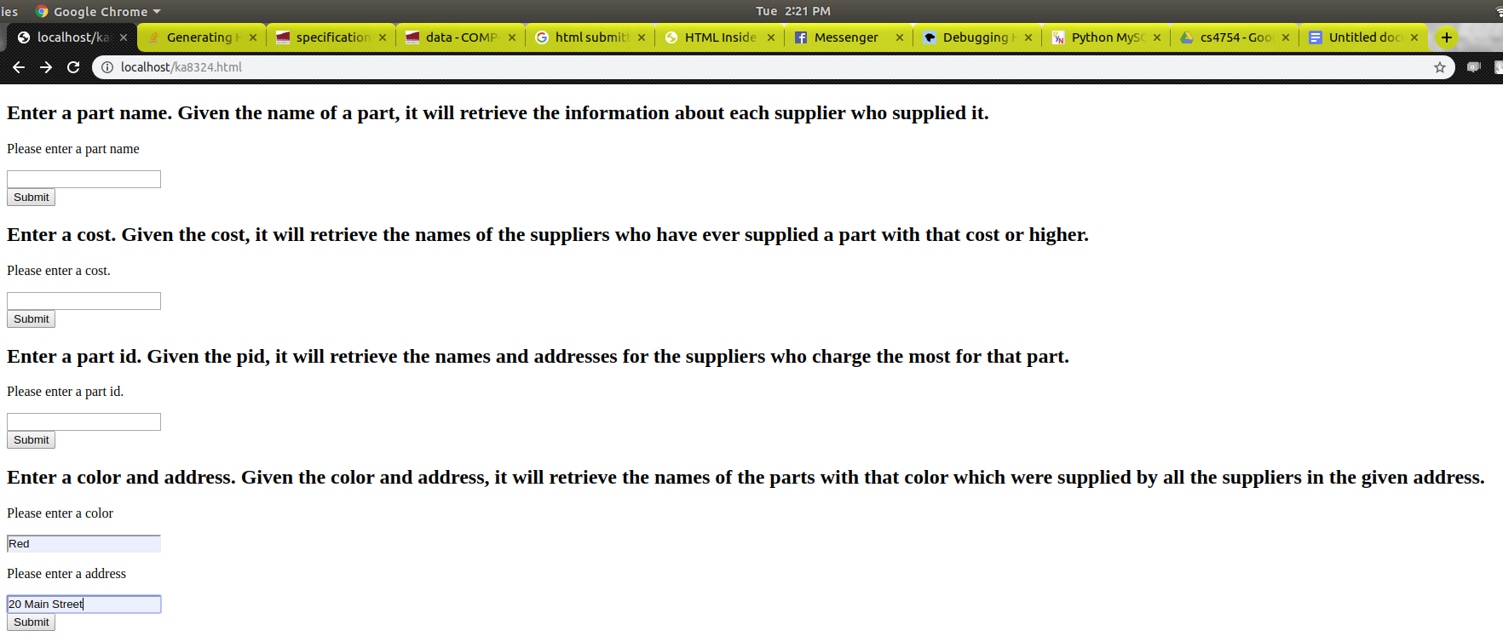

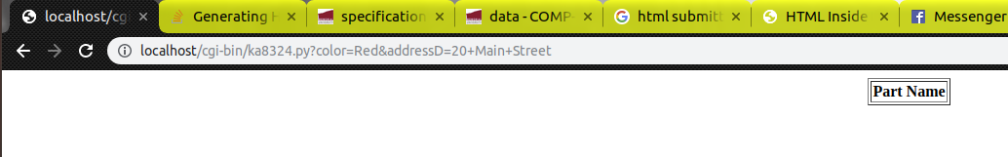

Here is proof my query works in MySQL on the terminal: 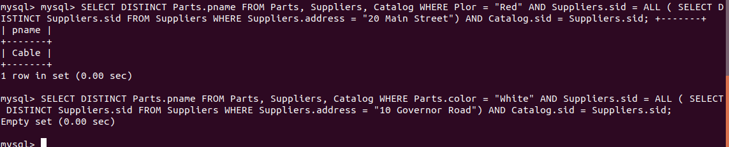

**Example Query E:**

